Investigating dynamic terrain as a novel mechanic to solve puzzles in games within a real-time physics simulation context



Mr Ashley Cromack  
CRO12450621

Project Supervisor: Dr. Grzegorz Cielniak

MComp Games Computing

University of Lincoln  
School of Computer Science

**ACKNOWLEDGEMENTS**

I would like to thank the following, for without their help this project would not have been possible.

Firstly, I’d like to thank my project supervisor Dr Grzegorz Cielniak, for offering continual help and guidance along the course of this endeavour, helping to structure and

I’d also like to thank my family for their unending support throughout my university career, never once has their belief in my abilities faltered and that has helped assure my confidence and kept me going throughout the years.

Finally, I’d also like to extend my thanks to Miss Millie Williams. Her love and support helped to keep me focused on delivering work to the best of my efforts.

Contents

Abstract 4

Background 4

Literature Review 7

Physics Simulation 7

Game Design 9

Puzzles in Games 10

Case Studies 11

Hardware 13

Methodology 14

Project Management 14

Software Development 15

Toolsets and Machine Environments 16

Research Methods 16

Design, Development and Evaluation 19

Software Development 19

Requirement Elicitation 19

Design 19

Coding 19

Testing 19

Operations and Maintenance 19

Research 19

Conclusion 19

Reflective Analysis 19

References 22

Appendices 0

Appendix 1 – Gantt Charts and Tasks 0

Appendix 2 – Game Design Document 1

Appendix 3 – Prototyping 0

Appendix 4 – Example User Consent Form 0

Appendix 5 – Example User Test Diary 0

Appendix 6 – Collated User Testing Data 0

# Abstract

**[WRITE AFTER COMPLETING THE PROJECT]**

# Background

As computational resources available continue to grow, games developers set their aims on implementing more facets of the physical world into their creations to heighten realism, this is where the idea of reproducing real-world physics into games came about. The usage of rudimentary physics simulation in games can even be dated all the way back to *Pong* [CITATION] with it’s simulation of a ball bouncing off walls and paddles, while this may seem incredibly simplistic by today’s standards it laid the groundwork for the vastly more complex systems we have now.

The demand for more elaborate physics simulations in games grew, this lead to the creation of dedicated physics middleware, engines devoted to the accurate and realistic simulation of physics in real-time. As of today, the most widely used and richly featured physics engines in the games industry are Microsoft’s *Havok* and Nvidia’s *PhysX*, *Havok* being the most popular choice among developers with over 400 games using it in some capacity (Havok, 2011). However, most modern physics engines all feature similar physics techniques that developers can then implement in their games, these can include:

* Rigid Bodies: A simulation of how solid objects are structured, which can then have Newtonian mechanics applied to them to model their motion.
* Collision Detection: A system of calculating whether two objects have collided (typically using a bounding volume) and determining an appropriate response.
* Ragdolls: A way of procedurally animating characters within a game to give them realistic movement and interact with the environment in a natural way.
* Particle Systems: A controllable set of individual physical particles that react to external forces and, in some instances, forces between each other. These are used to model things such as water, smoke, cloth and rain.
* Deformable Bodies: Giving objects the ability to either shatter, destruct or deform

This concept of deformable bodies presents a great many possibilities in how a game world can be impacted upon by the actions of the player as, while some methods to model bodies of this nature can be rather computationally expensive, it creates a much more accurate depiction of how objects behave in the real world.

The concept of presenting a puzzle to the player, which they then must solve with the mechanics available to them, has been a staple of video games for decades. Whether the puzzles define the core of the game, such as titles like *The Witness* (Thekla Inc., 2016), or they form small challenges along the way like in the *Uncharted* games (Naughty Dog, 2007), games developers are always searching for new and unique ways of testing a player’s problem-solving abilities.

The original aims and objectives from the project proposal were as follows:

* Aim:  
  To experiment with the concept of deformable terrain, using a real-time physics simulation context, as a novel mechanic to solve puzzles in a game. The impact of this mechanic in gameplay, how it affects a player’s perception of puzzles and how they can solve these puzzles using the tools at their disposal.
* Objectives
  + To investigate and experiment with the current implementations of physics systems and middleware to find a suitable basis to build a real-time solution for terrain deformation, such as *PhysX* and *Bullet*. Additionally, to explore ways to implement this system into a game, potentially through existing games engines like *Unity* and *Unreal Engine*.
  + The game should go through an extensive design and prototyping process to ensure that it delivers an enjoyable and coherent experience for the players, with focus on conveying the mechanics and how they operate clearly.
  + To successfully develop the game into a functioning prototype, demonstrating the implementation of terrain deformation that responds in an appropriate real-time context to the player’s interactions with it. The game will be designed with this player-controlled terrain deformation in mind as the primary tool for solving puzzles.
  + To evaluate the effect that using dynamic terrain as a game mechanic has on the gameplay experience and how it influences their approach to puzzle-solving. To do this the artefact will need to be presented to a group of play-testers to investigate what their experience with the concept was like, what components they enjoyed, and which features they gravitated towards, along with more quantitative data from logging their interactions with the game.

These aims & objectives provided a guideline for key areas that needed to be investigated for the outset of this project:

* Physics Simulation
  + As the focal point of this project, it is vital to explore the existing academic investigations into the subject of how to simulate physics in real-time, the various ways in which this can be achieved, the benefits and drawbacks of these implementations and then finding one that appropriately fits the scope of this project.
* Game Design
  + To justify the approaches made with regards to the design of the game produced for this project, existing literature that provides a framework of how to approach the design stage of this kind of artefact production, whilst also being sure to consider the focus that should be placed upon the deformable terrain aspect.
* Puzzles in Games
  + As this project focuses not only on the implementation of deformable terrain but also how it can be applied to puzzles, it is key to research the techniques employed in designing these puzzles, presenting them to the player and to place a focus on the deformable terrain mechanics the player will be using to solve them.
* Player Experience
  + It is important to consider the ways in which the artefact produced for this project would be evaluated regarding the aims and objectives laid out above. Therefore, appropriate research methods for evaluating the response of players to particular aspects of a game will need to be investigated.
* Case Studies
  + As with any piece of software development, it is imperative to explore the existing solutions to the problem that are already on the market (the problem in this case being that of encouraging greater fitness). With the somewhat serious nature that these applications take on, given that they are actively trying to improve the user’s personal health, it may be useful to see what research already exists on these types of applications and what they do successfully.

# Literature Review

Following on from the aims and objectives laid out prior, and the subsequent areas highlighted for investigation, the following academic literature has been explored and evaluated in the relevant areas.

## Physics Simulation

The first domain of research that was investigated was that of applications that have a focus on health-based or fitness applications, due to the product of this project having an underlying emphasis on the importance of this idea of improving personal health through an app (or game, in the specific case of this project).

In *A Review and Comparative Analysis of Security Risks and Safety Measures of Mobile Health Apps* (Scott, Richards and Adhikari, 2015) they outline the fact that mobile health applications typically provide convenient access to well-being resources and programs for the users. With this, the user will be entrusting some degree of their personal health information to the application, hence there lies a degree of risk and responsibility to keep the users’ data safe. In the context of this project, the only data that the user is divulging is the number of steps they take within a time, therefore there is not as much data to keep secure as opposed to the more intensive health applications that the paper discusses. However, it was still important to consider the recommendations and risk safety features that they outline to ensure that even the step data that the user is divulging to the application is not at risk of being misappropriated.

Another relevant paper in this area of research was *Apps to Promote Physical Activity Among Adults: A Review and Content Analysis* (Middelweerd et al, 2014) which concentrated on investigating a sample of ‘health and fitness’ smartphone applications and how they applied established techniques to achieve health behaviour changes. Through their sample of 64 apps they found that, on average, these included 5 behaviour change techniques. The most common techniques employed were self-monitoring, providing feedback on performance and goal-setting. These techniques were therefore taken into consideration when designing the game for this project, in order to assure that it could be as successful as possible in its aim to encourage greater fitness by adopting the health behaviour change techniques that are widely used in the industry.

Another study which focused on the area of health behaviour was *Health Behaviour Theory in Physical Activity Game Apps: A Content Analysis* (Payne, Moxley and MacDonald, 2015), where the researchers aimed to quantify the elements of health behaviour theory in physical activity smartphone games. From their research, they found that games in this category demonstrated higher levels of behaviour theory than non-game applications, though it was unclear whether this was intentional or just inherent to games. This may not be definitive however, so it was essential to bear this in mind when designing and developing the game for this project to ensure whether these behaviour-changing techniques were definitely present, as it may not have been as successful in encouraging physical activity if they were not.

In *Development and Implementation of a Smartphone Application to Promote Physical Activity and Reduce Screen-Time in Adolescent Boys* (Lubans et al, 2014) the researchers detailed their development process for creating an app to encourage adolescent boys, particularly those “at-risk” of obesity, to engage in more physical activity. Through this study, they found that while the participants reported that the app provided them with new techniques and routines, their actual engagement with the app was somewhat limited. This became an area of focus when carrying out this project, several ways of ensuring audience retention were investigated as a result to try and avoid the risk of the final game being met with similar limited use. However, as they note, some of this this could have simply come about due to the adolescent targets of their study who may find it difficult to stick to self-monitoring physical activity, unlike adults who tend to use this strategy extensively.

A study that looked at a demographic most relevant to this project’s target users can be found with *Health and Fitness App Use in College Students: A Qualitative Study* (Gowin et al, 2015) where the researchers looked at college students (university students, in British terms) who reported use of health and fitness applications. Upon conducting interviews with these students, the researchers found that most downloaded these apps to meet a goal, which they found the app helped them to achieve, and that they mainly either got these apps to support an established behaviour or to adopt a new one. They also found that many of the apps these students used were easy to use, provided audio/visual cues as to how they were doing and had aspects of gamification, especially with rewards. It therefore became clear that usability was an immensely vital component to consider, alongside gamification, in order to encourage use of the game produced in this project.

Aside from traditional game design, it was clear that specific considerations also needed to be taken into account when developing a game with a health focus, *Designing for Healthy Lifestyles: Design Considerations for Mobile Technologies to Encourage Consumer Health and Wellness* (Consolvo et al, 2012) outlined some of these design practices that should be followed. Of particular note, they ascertained that allowing the user to set their own goals, as well as being presented with feedback to monitor how they’re doing, was incredibly important when creating an app to encourage healthier lifestyles. When designing the game for this assignment it was therefore paramount to ensure these aspects, or ones to evoke similar actions for the user, were implemented into the design.

A key factor that also plays into the construction of health and fitness applications is how to encourage the user to continue interacting with it in the long term, which was the focal point of *What Motivates Users to Continue Using Diet and Fitness Apps? Application of the Uses and Gratifications Approach* (Lee and Cho, 2016). The ‘Uses and Gratifications’ approach of this study found that, out of the identified seven potential motivations for users to continue their use of fitness apps, the five that most significantly influenced this behaviour were as follows: credibility, comprehensibility, recordability, networkability and trendiness. Credibility and comprehensibility both relate to the data the application shows the user, therefore this demands that the step data from this project’s game feels accurate and can easily be interpreted by the user, with recordability being to allow users to keep track of this data. The aspect of networkability referred to allowing users to communicate and interact with each other within the app, which was not particularly applicable to the hardware platform of choice (smartwatch) in this project due to its limitations not being conducive to communicating. The last point of trendiness is more of a conceptual zeitgeist, relying on what the general populous would consider to be ‘cool’ and ‘trendy’ in the world of technology.

One way of looking at the problem of encouraging users to engage in greater physical fitness is that the users need to be ‘persuaded’ into being more active, which was explored in *Persuasive Technology for Smartphone Fitness Apps* (Yoganathan and Kajanan, 2013). In this conference, the researchers investigated the idea that the inclusion of persuasive design principles in these kinds of applications can help their efficacy of causing those kind of behaviour changes. The principles from this theory can be largely applied to behaviour changing techniques outlined in other papers, so this provides another perspective to look at the design choices that can be made when designing apps of this nature. The concepts of ‘self-efficacy’ and ‘self-regulation’ provided the most applicable to this project’s game, though the idea of ‘social facilitators’ yields many factors that would be incredibly important for any competitive features of the game.

A paper that focused more on the implementation side of how games encourage users to exercise can be found in *Exergames for health and fitness: the roles of GPS and geosocial apps* (Boulos and Yang, 2013). In their study, the researchers reviewed different examples of ‘exergames’ that utilise GPS in some way to get the players to exercise more outside. While they found many issues with the use of GPS in these games, such as the sensor failing when in covered areas or games that randomly generate items on a map could pose risks to the player’s health should they be in a dangerous location, these location-based exergames are still very valuable (especially to get younger people to exercise more). The use of GPS was considered during the course of this project, however not all smartwatches feature this functionality and the use of location-based information proved challenging given you would not realistically be able to display a map on the smaller screen of a smartwatch compared to that of a smartphone.

## Game Design

Due to this project’s focus on creating a game to encourage fitness, it was also imperative to investigate the area of game design, the use of components of games and frameworks for their design.

One such well documented framework for game design was *MDA: A Formal Approach to Game Design and Game Research* (Hunicke, LeBlanc and Zubeck, 2004) which is a widely-studied framework throughout the field. This framework focuses on how the player interacts with the distinct levels of a game’s makeup and how the designer should approach creating them, these levels being the mechanics, dynamics and aesthetics that make up MDA. Due to its ubiquity throughout the research field of game design, the MDA framework was an important consideration during the design process of producing the game for this project.

Another relevant research paper, *On the Media Practice of Highscoring* (Reisner, 2016), investigated the concept of highscores in games, how it provides a framework to look at developments in other social domains and how it plays into the concept of gamification. A large portion of this article centres on how game highscores came about historically and how they can be used to highlight some aspects of society prevalent at the time of the game’s production. More relevant for this project however, came when they discussed the potential of highscoring in the domain of physical fitness, where they essentially discuss the idea of gamifying fitness. Though they approach it with gym-like machines in mind, this concept could easily be applied to mobile games on smartphones or indeed smartwatches, so this provided a key consideration of how to bring over this phenomenon of gamers trying hard to reach new high-scores but in the context of a fitness game tracking your steps.

## Puzzles in Games

The key concept to achieving the aim of this project is that of gamification, of relevance being its application to physical fitness. Therefore, it was of particular importance to investigate the current state of research into gamification and how this can be applied with this project.

As was briefly analysed in this project’s proposal document, *Gamification: The Intersection between Behaviour Analysis and Game Design Technologies* (Morford et al, 2014) provided a useful starting point to investigate gamification and gave some examples of its’ benefits with health-related behaviour. This paper described the concept of gamification in-depth, how game design can be used to implement features of this in various types of software, including those that focus on the ideas of behavioural health and fitness. In addition to this, the researches provided a selection of examples to highlight successful uses of gamification in changing health behaviour, which served as a useful guide of what good examples of existing software there is on the market. This paper also outlines the idea of ‘behaviour-traps’, where successful games are concerned with keeping players engaged so they introduce elements such as story and rewards systems in order to keep the player interacting with the game. This concept was important to consider with this project as it serves as a way to encourage greater physical fitness by ensuring that the player will engage with the game for a longer period of time, thereby coercing their fitness behaviour to change.

Another paper that broke down the idea of gamification and it’s use for promoting improved fitness was *Deconstructing Gamification: Evaluating the Effectiveness of Continuous Measurement, Virtual Rewards and Social Comparison for Promoting Physical Activity* (Zuckerman and Gal-Oz, 2014), where the researchers developed a mobile app prototype to promote walking. With producing this prototype and determining its effectiveness through field studies they found that, while gamified aspects of the application were effective in their goals, they were not inherently better than simply providing the user with continual measurement, a goal and real-time feedback on how they are progressing. It therefore highlighted the point that simply gamifying a fitness does not immediately lead to increased engagement, and that it should be applied in conjunction with the more pedestrian fitness app features of goals, tracking and measurement.

A study that investigated the application of gamification in current health and fitness apps on the market can be found in *Just a Fad? Gamification in Health and Fitness Apps* (Lister et al, 2014), where they conducted a review of 132 apps to identify the extent to which gamification is used in these apps and how it may be utilised to influence the users’ health behaviour. From this study, it was discovered that the use of gamification in this sector of the app marketplace is immensely popular, but they showed a lack of essential elements of behavioural theory being implemented which lends to the concern that the effectiveness of these apps to change the users’ behaviour. To assure optimal effectiveness for this project’s aims, these aspects of behavioural theory were considered when designing the various aspects of the game.

Another paper that evaluated the use of gamification in terms of encouraging health behaviour changes was *Gamification for health promotion: systematic review of behaviour change techniques in smartphone apps* (Edwards et al, 2016). In this paper, the researchers reviewed various health applications, that all featured gamification in some way, which were available on the iOS and Android app stores. From their research, they found that few health apps successfully employed gamification and they all widely varied in their use of behaviour change techniques. While there was no direct evaluation of the techniques used, the most popular ones were shown to be ‘self-monitoring of behaviour’, ‘non-specific rewards’ and ‘non-specific incentives’. Due to their popularised use in existing applications, these proved to be important parts of behaviour change theory to focus on, in accordance with the previously mentioned piece of literature, when designing the game in this project.

Straying away from looking directly at applications for smartphones and similar platforms, *Gamification Solutions to Enhance Software User Engagement – A Systematic Review* (Darajeh and Salim, 2016) instead investigated how gamification is employed with all software. With this, the researchers conducted a review of studies in the field of gamification to see which areas of research have been investigated to an extensive degree and those that are yet to have said research carried out. While this may have proved useful when setting out the initial goals of the project and its area of investigation, it however serves as a useful way to contextualise where this project falls as a study within the existing domain and what considerations could be made in future work to allow a similar project to further the field even more.

## Case Studies

To contextualise the primary concepts that this project investigates, it was important to find case studies that look at how existing applications that gamify fitness were designed, how successful they were in their aims and whether anything can be learned from their existence on the market.

Whilst being aimed at a younger audience than the target demographic for game in this project, the paper *BunnyBolt: A Mobile Fitness App for Youth* (Keung et al, 2013) details the design and development process of the titular application ‘*BunnyBolt’*, which helped to provide a potential framework for how to produce this project’s game. ‘*BunnyBolt’* follows a similar format of games like ‘*Zombies, Run!’* (Six to Start, 2012)where the player is presented with an interactive, map-based game that encourages them to exercise, however its’ features are inherently more child-friendly. One key factor that this paper highlighted was how best to encourage players to engage in exercise outside and how to assure this. They found that existing games that used pedometers were easily cheated by players who would soon find out that they could simply shake the pedometer to simulate steps, hence they elected to use GPS sensors built into current mobile devices. However, the pedometer sensors inside the smartwatch hardware utilised in this project are not so easily tricked and therefore proved to be a sufficient sensor to use (though this potential use of GPS in certain hardware models may prove an interesting way to further the concept of this project in the future). Another important aspect that this paper highlighted was how to reward users for playing in the game, as they found this helped to ensure players would have an incentive to keep playing and enjoy themselves, consequently the idea of quantifiable rewards for playing was integrated into this project’s game.

An additional case study that was investigated is that of *‘Pokémon Go’* (Niantic, 2016), brought to light in the paper *Influence of Pokémon Go on Physical Activity: Study and Implications* (Althoff, White and Horvitz, 2016). As they highlight, *‘Pokémon Go’* was a global phenomenon when it launched in July 2016 and encouraged numerous people to engage in exercise, hence it was an important existing product to study. Through their analysis, they found that *‘Pokémon Go’* lead to significant physical activity increases over a period of 30 days, causing engaged users to increase their activity by more than a 25% increase on their previous level of activity.They additionally estimated that, in the time of their study, the game added 144 billion steps to US physical activity across all ages and genders, indicating the degree of success this game found in its aim to encourage fitness. Though this study focuses on the direct results of the game’s design to people’s physical fitness, they do not delineate the exact components of the game which cause these fitness benefits. Therefore, it proved necessary to investigate the game, break down it’s different mechanics and how they work together, as this paper shows they must be successfully implemented. In *‘Pokémon Go’* the key components appeared to be the sense of discovery when the player finds new things, the personal goal setting of ‘hatching eggs’ that have distance meters attached to them and a medal system, like *BunnyBolt*, which rewards the user for playing the game.

While these existing examples of applications that gamify fitness proved useful to contextualise how to successfully encourage fitness through game design, they are all developed on smartphone platforms which all have a greater computational budget, feature set and larger screen to develop the game around compared to smartwatches. This means that the main things to take from these case studies is how they conceptually work rather than how they are literally implemented, as the limitations of the smartwatch hardware platform means that these complex features are not all possible to implement.

## Hardware

For the domain of smartwatches there are not a copious amount of research papers available, however one paper that was considered in the project proposal was *How Accurately Can Your Wrist Device Recognize Daily Activities and Detect Falls?* (Gjoreski et al, 2016). This paper placed a focus on the sensors within wearable technology, such as smartwatches, and how accurate the data they retrieve is. The most relevant information from this study was that the more accurate measurements were garnered when the device was worn on the left wrist, which was utilised upon real-world testing with smartwatch in this project to achieve the most accurate results. However, given that this project focuses more on the gamification systems put into place to make a game out of fitness, trying to obtain purely accurate results wasn’t a primary concern, though it does help the user feel like they can rely on the credibility of the step tracking done by the game.

# Methodology

## Project Management

For this project, there were key processes that needed to be identified and outlined to find a project management method that best fit. The project was broken down into 5keycomponents: Research, Design/Prototyping, Development, Testing and Documenting. It was also important to consider that, due to the nature of this project, this is the work of an individual and the amount of time available to work on it is limited. This was especially important when finding a way to best manage the project.

To facilitate this, various management techniques were investigated to see which would best suit the goals of this specific endeavour. Through these investigations, it was discovered that the UK government have their own standard set for information systems projects, this being the PRINCE2 method, due to its importance in the UK technology industry it was therefore considered. However, it was soon determined that this methodology would not be entirely appropriate for the scope of this project as, while it claims to be scalable, the amount of additional paperwork it demands would not have proved viable given the time limitations of this project (especially as it is a solo endeavour). This still proved to be a useful method to investigate, especially for future software development projects, due to its importance within the UK technology sector.

The methodology that was finally chosen as the basis for this project was a tweaked version of the agile method. This method was selected as it offered the most flexibility out of all those investigated, which was an invaluable characteristic as, due to the individual nature of this project, it would need to continually adapt along the way. This methodology was recently analysed in *Analyzing Agile Development – from Waterfall Style to Scrumban* (Stoica et al, 2016), where they outlined that agile development allowed for tasks to be executed quickly and easily be adapted when needed. This was especially important for this project as, due to the nature of this project being undertaken alongside other pieces of work, some aspects of the project needed to be able to change on the fly (especially the timeframe on which tasks were planned on being completed and the actual tasks that need completing).

The 5 components of this project were discerned in the Gantt chart produced in this project’s proposal. This chart proved invaluable when trying to chart the progress of the project and whether the various tasks that were outlined were being completed on time. However, over the course of carrying out the project, the timeframes of some sections lined out in the original Gantt chart meant that some tasks would’ve ended up being incredibly difficult to complete to a reasonable level in the time. This meant that the Gantt chart saw several iterations as certain tasks required more and some required less time to complete. The original Gantt chart can be seen in Figure 1, and the final variation of it can be seen in Figure 2.

**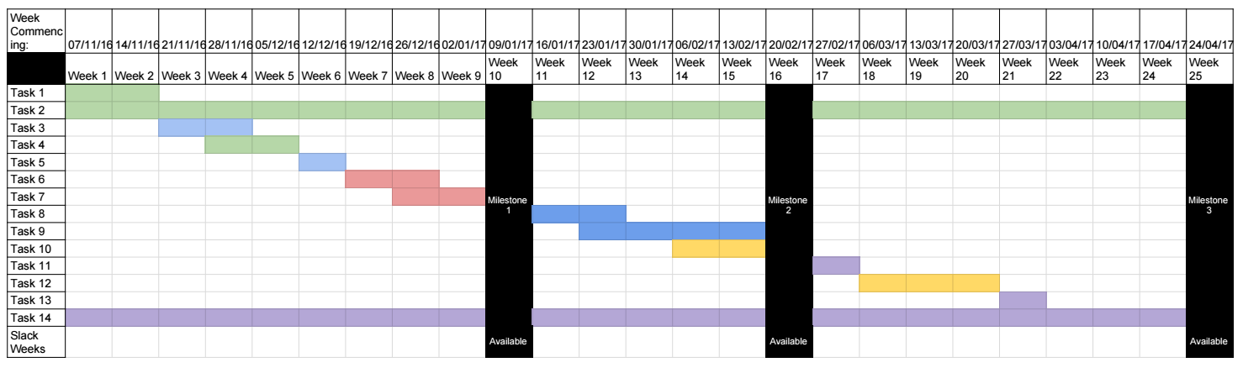  
^ Figure 1: Original Gantt Chart**

**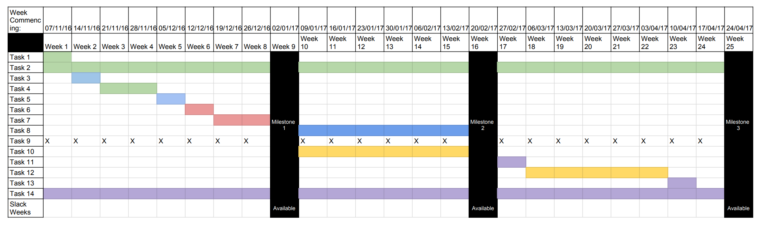  
^ Figure 2: Final Altered Gantt Chart**

Larger versions of the charts, along with the list of relevant tasks, can be found in Appendix 1. This changing nature of the chart allowed it to be more versatile, however this raised issues of having a set project schedule to stick to. Additionally, some tasks needed to be changed during the project, for instance the task to implement a leaderboard system was completely scrapped due to it not being a particularly viable feature on the smartwatch hardware platform as a result of the limited screen size and unlikely connection to the internet when walking about outside.

## Software Development

A methodological analysis of software development approaches used should be included, taking into consideration the characteristics of the software being developed and the computer environment requirements. Once again, be sure to support the chosen methodology with appropriate, recent academic references.

You may want to give thought to how you collected the requirements of the software being developed, did you collect data from people, use academic literature or some other way.

Do not simply discuss software development or explain how typical methodologies work (spiral, waterfall, etc.)

## Toolsets and Machine Environments

Outline the tools for both software development and project management, make appropriate comparisons between the tools available and argue for the most appropriate selection.

Do not justify the grounds for using certain tools simply on prior experience or skills developed.

Discuss possible machine environments under which the artefact may be required to operate and, through analysis, comparison of features and possible user requirements, a determination of the chosen environment(s) will be made.

Tools for project management

* Microsoft Excel
* Google Calendar

Tools for software development

* GitHub
* Physics Engines
  + PhysX
  + Havok
  + Bullet
* Games Engines
  + Unity
  + Unreal Engine

With regards to the software development side of this project, there were some vital components that needed consideration. Chief among these was how to appropriately model the physics in the produced artefact, as there are many approaches that could be taken. The first way in which this could be achieved is to produce the physics functionality independently

## Research Methods

To evaluate how successful this project’s game is in its goals, it needs to be judged in how well it encourages users to engage in physical fitness. For this the smartwatch and game were given to volunteers who engaged in a short-term test, in this test they were asked to use just a basic step tracker for 3days and then to use the game to track their steps for the same amount of days. At the end of each day they were asked to note down how many steps they had taken that day according to the relevant application they were using. Examples of the consent form the users were presented with and the testing diary that they were asked to fill in can be found in Appendix 4 and Appendix 5 respectively. Additionally, the collated data from these user tests can be found in Appendix 6, to visualise this information the following Figure 5 and Figure 6 show the users’ engagement with the standard tracking app and the game produced in this project.

**Figure 5: Standard Step Tracker Use**

**Figure 6: Game Step Tracker Use**

As these figures show, in general, most users displayed a noticeable increase in the number of steps they took when using the game to track their steps over the traditional step tracking app. This potentially shows that the application of gamification to fitness in this case has helped to encourage users to engage in physical activity. However, as the graph shows, there are noticeable signs that some people were quickly diminishing in their number of steps taken even when playing the game. This could highlight the issue that research found where encouraging sustained use of these kinds of applications is difficult to achieve, so further iteration may be needed to ensure this.

There were some notable comments that testers made over their time with the device and use of the applications, one of which being that the continual need to recharge the smartwatch at the end of each day soon became a bit of a chore and was far from convenient. This highlights a key issue with the very hardware that this software was designed for, in that it simply doesn’t factor smoothly into consumers’ daily routines and that adding another device that users need to worry about keeping charged may deter them from using the hardware altogether. Another important note that testers made was that, although the game had them engaged at the beginning, they soon felt like they’d experienced most of the mechanics at play and were not sure whether they would’ve continued to keep playing much longer after the testing period. Therefore, to combat this in future, a greater breadth of varied content will need to be produced to make players feel like they’re always discovering something new. Perhaps the use of procedural content generation with the way in which encounters work and what kind of enemies the player comes across feel like to play against.

Due to the scope of this project being primarily that of development and implementation rather than research, the limitations of time and testing hardware available, the data-set used is rather small in this instance. This is more to gain a rough insight as to how successful the solution presented here appears to be to people who have had no previous interaction with the project. If this project did indeed have a larger research scope of investigating the efficacy of gamification in smartwatch fitness apps, it would be better to test a far greater and varied group of test subjects in order to gain more insight into the specific instances where it is effective and where it falls short.

# Design, Development and Evaluation

???

## Software Development

???

### Requirement Elicitation

???

### Design

???

### Coding

???

### Testing

???

### Operations and Maintenance

???

## Research

???

# Conclusion

In this section report your findings, answering any research questions posed. This section should be understandable to people who just want to get a general picture of the work and its results.

# Reflective Analysis

In general, this project ran smoothly, however there were areas that could have done with improvement and some areas that could be expanded in further projects.

The development process of producing the game went successfully but had resulted in some scaled back ambitions from the original ideas I had for the design back at the start of the process. For instance, it was originally planned to have a form of leaderboard system in the game to allow players to compete and see how their friends are doing, which I anticipated using the Google Play services to achieve. However, one immediate issue that sprung up in practice was that the size of the smartwatch made the concept of a leaderboard extremely difficult to implement in a way that the player would easily be able to interpret and interact with. This planned implementation therefore was scrapped in favour of having a personal rewards system for the player in order to encourage them to play the game, which falls in line with many of the academic papers that I investigated over the course of this project. I do however feel that this competitive element could vastly help to encourage engagement with similar games, perhaps those that use the more lucrative size and resources of a smartphone. Therefore, I feel a project that aims to produce a similar type of game but for smartphone platforms could stand to investigate the potential benefits that this feature could have for encouraging prolonged and more intense engagement leading to greater improvements in physical activity.

Another issue that arose was that of asset creation for the game, as this wasn’t an aspect I had considered when beginning work on the game as I wanted to ensure that the code and logic were all in working condition first. However, it became apparent very quickly that to make the product look more professional and have a greater degree of polish, an attractive selection of screens and pictures would need to be produced. Due to my limited experience regarding this kind of asset creation, the final 2D 8-bit style sprites created were not quite of the highest visual fidelity or variation that would be best for a commercial product. Though this may not have been massively important for the scope of this project, I would still consider devoting a bit more time to producing higher quality visual assets for the game in a future project. This is because I feel, from personal experience, having a more visually appealing and professional product may help to encourage people to engage with the game as an attractive façade is likely to encourage greater confidence in the mechanics behind it.

One issue that arose regarding the management of this project was that the earlier tasks outlined in the original Gantt chart turned out to be particularly trivial in relation to other tasks that needed to be completed in the project. This meant that, when trying to follow the original chart at the beginning of the project, the initial tasks were completed very quickly and resulted in a sort-of complacency concerning the state that the project was in, resulting in some lost time that could have been invaluable in later stages of the project’s development. While the Gantt chart was adapted over the course of the project, this constantly changing nature of it became somewhat challenging to keep track of what tasks should be done at what points and when I should stop altering it. In retrospect, I would’ve instead made the original Gantt chart with the anticipation of it being adapted in mind, and factoring that into its setup. However, I feel the inclusion of milestones set throughout the course of the project’s run was incredibly important as it gave a more solid idea of what tangible elements of the project should be together at what points in the timeline. Though, to this, I would in future add milestones for the report’s sections being completed, as this would’ve helped to ensure that the report also had elements completed earlier therefore allowing for further edits and additions.

Another note that I would make on the smartwatch domain of this project is the market relevance of the platform in the technology industry. During the undertaking of this project, analysts IDC published their market analysis of smartwatches (IDC, 2016) which painted a particularly bleak picture, noting the market had declined by over half in Q3 2016. In their report, they provided the data indicating the shipments of smartwatches from various manufacturers and their respective market share.

The shipment data in Figure 7 demonstrates that, while manufacturers such as Garmin saw dramatic relative increases in shipments, the overall number shipped by all noted manufacturers had dropped massively (most notably by market leader Apple’s over 70% decrease in units shipped). This suggests that the public interest in smartwatches has waned incredibly quickly and that, unless a product is introduced in the category to change this perception, this is a market that could struggle to gain any relevant traction. However, as can easily be identified through the limited amount of data provided with this analysis, the market is somewhat in it’s infancy, so perhaps this dramatic change in shipments could be attributed to the fact that it’s a piece of hardware still yet to be proven to consumers.  
Another note to make however, the company Pebble that is included in that information has since been bought out by other wearables company Fitbit. As WIRED noted in their article *Sinking like a Pebble: is the Fitbit buyout a sign the wearables market is doomed?* (WIRED, 2016) devices that run sophisticated operating systems tend, like smartwatches, tend not to be very successful. Of importance in this article is the comment that consumers are shifting away from smartwatches to more simplistic fitness trackers, and that they don’t want gimmicks on their wearables and instead want something that “looks good” and has “the basic features they need”. This means that more complex applications, like the game produced in this project, and the ecosystem around them may not be of relevance as the market moves on. If a game in this manner is to succeed in the current market, it would need to be hardwired into a simpler device that attracts users, instead of the more functional but seemingly overwhelming smartwatch platform.

# References

McKeown C. (2016) Alternative Trajectories: Structuring play through videogame physics engines. Performance Research, 21(4) 95-99.

Vahdat, M. Carvalho, M. Funk, M. Rauterberg, M. Hu, J. and Anguita, D. (2016) Learning Analytics for a Puzzle Game to Discover the Puzzle-Solving Tactics of Players. In: Adaptive and Adaptable Learning. EC-TEL 2016, Lyon, France, 13-16 September. Cham, Switzerland: Springer, Cham, 673-677. Available from ? [accessed 27 March 2018]

Ullman, T. Spelke, E. Battaglia, P. and Tenenbaum, J. (2017) Mind Games: Game Engines as an Architecture for Intuitive Physics. Trends in Cognitive Sciences, 21(9) 649-665

Law, B. (2016) Puzzle Games: A Metaphor for Computational Thinking. In: 10th European Conference on Games Based Learning: ECGBL 2016, Paisley, Scotland, 6-7 October. Reading, UK: Academic Conferences and Publishing International Limted, 344-353. Available from ? [accessed 27 March 2018]

Carvalho, J. Duarte, L. and Carriço, L. (2012) Puzzle Games: Player Strategies across Different Interaction Modalities. In: 4th International Conference on Fun and Games, Toulouse, France, 4-6 September. New York, USA: ACM, 64-72. Available from ? [accessed 28 March 2018]

Stege, L. Lankveld, G. and Spronck, P. (2012) Teaching High School Physics with a Serious Game. International Journal of Computer Science in Sport, 11(1) 123-134

Reed, S. (2015) The Structure of Ill-Structured (and Well-Structured) Problems Revisited. Educational Psychology Review, 28(4) 691-716.

Zhou, Z. and Wu, L. (2012) The Study of Principles of Puzzle Game Design. In: 2012 International Symposium on Information Technology in Medicine and Education, Hokkaido, Japan, 3-5 August. ???

Price, C. (2007) The usability of a commercial game physics engine to develop physics educational materials: An investigation. Simulation & Gaming, 39(3) 319-337.

Pavel Zagrebelnyj (2014) *Spintires* [game]. Gorleston-On-Sea: Oovee Game Studios. Available from http://www.spintires.com/ [accessed 11 October 2017]

Prautzsch, H., Schmitt, A., Bender, J. and Teschner, M. (2009) Soil Deformation Models For Real-Time Simulation: A Hybrid Approach. In: *Proceedings of the 6th Workshop on Virtual Reality Interaction and Physical Simulation*, Karlsruhe, Germany, 2009. Graz, Austria: Eurographics, 21-30. Available from https://www.researchgate.net/profile/Torsten_Kuhlen/publication/221622677_Soil_Deformation_Models_for_Real-Time_Simulation_A_Hybrid_Approach/links/0912f50c196bf67fbc000000.pdf [accessed 14 October 2017]

Valve Corporation (2007) *Portal* [game]. Bellevue: Valve Corporation. Available from http://store.steampowered.com/app/400/Portal/ [accessed 14 October 2017]

Valve Corporation (2004) *Half Life 2* [game]. Bellevue: Valve Corporation. Available from http://store.steampowered.com/app/220/HalfLife_2/ [accessed 14 October 2017]

Wang, N and Hu, B.G. (2010) Aeolian Sand Movement and Interacting with Vegetation: A GPU Based Simulation and Visualization Method. In: *2009 Third International Symposium on Plant Growth Modeling, Simulation, Visualization and Applications (PMA)*, Beijing, China, 9-13 November. New Jersey, USA: IEEE, 401-408. Available from http://ieeexplore.ieee.org/abstract/document/5474660/?reload=true [accessed 15 October 2017]

Wang, D., Zhang, Y., Tian, P. and Yan, N. (2009) Real-Time GPU-Based Visualization of Tile Tracks in Dynamic Terrain. In: *CiSE 2009. International Conference on Computational Intelligence and Software Engineering*, Wuhan, China, 11-13 December. New Jersey, USA: IEEE, 1-4. Available from http://ieeexplore.ieee.org/abstract/document/5365552/ [accessed 14 October 2017]

Zhang, Y., Wang, D., Yan, N. and Shang, Y. (2010) Real-Time Visualization of Tire Tracks in Large Scale Dynamic Terrain. In: *3rd IEEE International Conference on Computer Science and Information Technology*, Chengdu, China, 9-11 July. New Jersey, USA: IEEE, 263-266. Available from http://ieeexplore.ieee.org/abstract/document/5565005/ [accessed 15 October 2017]

New References

njjkkkkklklmn

# Appendices

## Appendix 1 – Gantt Charts and Tasks



Original Project Gantt Chart



Final Project Gantt Chart

Table of Project Tasks and Milestones Relating to Gantt Charts

|  |  |
| --- | --- |
| Task Number | Task |
| 1 | To investigate the development platforms that are available and determine which would be best for this project, also look into the supporting documentation available for said platform. |
| 2 | Investigate any and all academic literature that holds relevance to what is looking to be done in this project and may help along the way to guide how the project takes shape. This therefore overlaps the entirety of the timeline, as it will be important to try and find relevant academic literature to each task that is being performed. |
| 3 | Experiment with the development platform, get familiar with the coding language used and how to develop basic applications for smartwatches. |
| 4 | Investigate the development APIs available to make use of the sensors available in the smartwatch hardware, as well as ways to store the data retrieved. |
| 5 | Implement the sensor APIs into a basic application along with data storage, configure into a working application. |
| 6 | Draft up designs and paper prototypes for what the game could look and behave like. |
| 7 | Rework drafted designs and ideas into a more polished product. |
| Milestone 1: The prototyping and design phase of developing the project should be complete by this point | |
| 8 | Begin developing this prototype into an application. |
| 9 | Implement the leaderboard functionality into the game. |
| 10 | Personally test out the state of the application & tweak (overlaps with development of the application to portray these ongoing tweaks). |
| Milestone 2: The coding for the game should be complete, ready for testing | |
| 11 | Write up a consent form for the user testing |
| 12 | Carry out user testing. |
| 13 | Compile the results of the user testing and see what conclusions can be drawn from them. |
| 14 | Write up project report. This overlaps the entirety of the project to demonstrate that this will be an ongoing task that will be contributed to at all points in the timeline of the project. |
| Milestone 3: The project should now be fully completed | |
| Slack Weeks: Weeks that are available, should a task take longer than originally anticipated these can then be filled. | |

## Appendix 2 – Game Design Document

**Game Name: Step Quest**  
Theme: Role-Playing Game  
Target Platform: Smartwatch – Android Wear (Sony Smartwatch 3)

Concept:

The player is initially presented with a selection of characters to choose from, whichever character they choose will serve to be their avatar for the duration of their time playing the game.

In traditional role-playing game style the player can earn experience points in order to level up their character and become stronger in order to win more battles. To earn this experience the player needs to engage with the fitness aspect of the game and walk around to raise the pedometer’s step count, this directly feeds into their character’s experience pool.

The primary reason for doing this is to raise their character’s strength for when they encounter a number of random battles that can pop-up as they are walking around. Upon running into one of these random battles, the player is taken to a battle screen where they are presented with themselves, an enemy, both their health bars and an option to attack by tapping on their character’s weapon. Tapping on this weapon will cause the player to attack, causing damage to the enemy’s health by drawing from the player’s strength stat, which they have built up by walking around and levelling up.

The reward the player gets from completing these battles is randomly selected from a number of options, they could:

* Gain a flat bonus to their current experience
* Gain a timed multiplier for their experience gain
* Gain a bonus to their strength
* Gain a bonus to their HP

In addition to this, upon completing battle milestones (such as winning 1 battle, winning 10 battles, winning a battle without losing any health etc.) they can also be rewarded with badges. These badges can be accessed from the character screen and can be used to track their achievements throughout their game playing time, and ideally encouraging them to play more to earn further badges.

However, should the player lose one of these battles they will be punished for doing so. Again, this will draw randomly from a selection of potential punishments, such as:

* A small subtraction from their current experience
* A decrease in their character’s strength
* A decrease in their character’s HP

The aim is for this to then encourage the player to go out and walk more in order to strengthen up their character before they encounter another battle, thereby decreasing the chances of them being punished for losing again.

## Appendix 3 – Prototyping

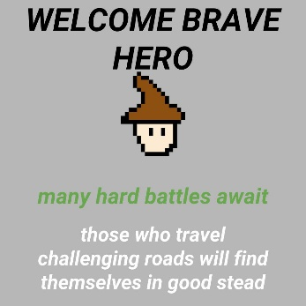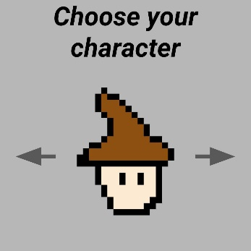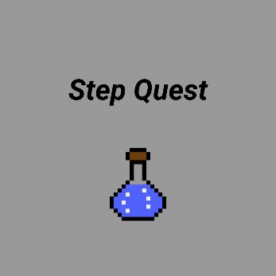

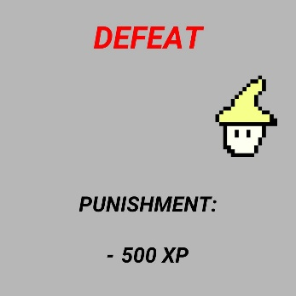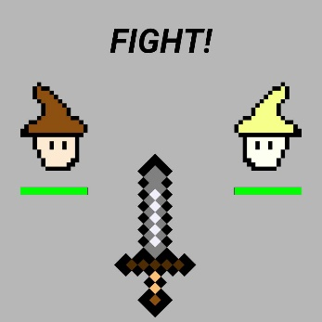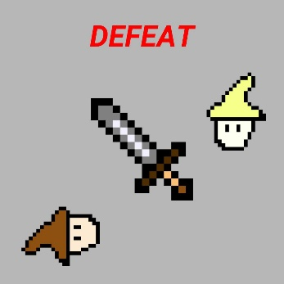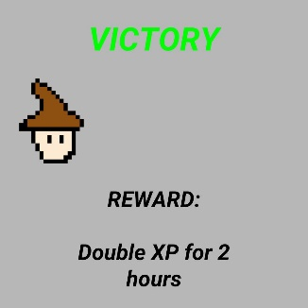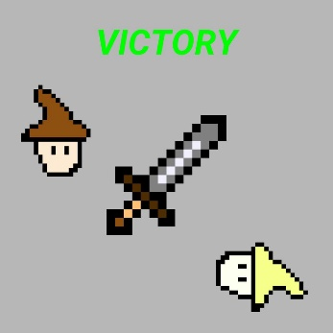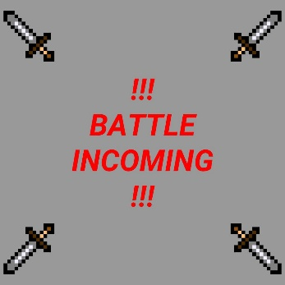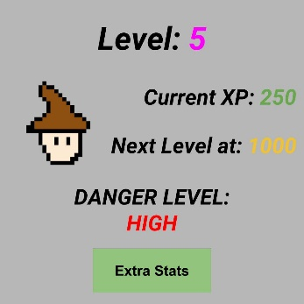

**10**

**9**

**8**

**7**

**6**

**5**

**4**

**2**

**3**

**1**

Screens:

1. Splash Screen
2. Character Selection Screen
3. Welcome Screen
4. Character Stat Screen
5. Incoming Battle Screen
6. Fight Screen
7. Victory Screen
8. Victory Reward
9. Defeat Screen
10. Defeat Punishment

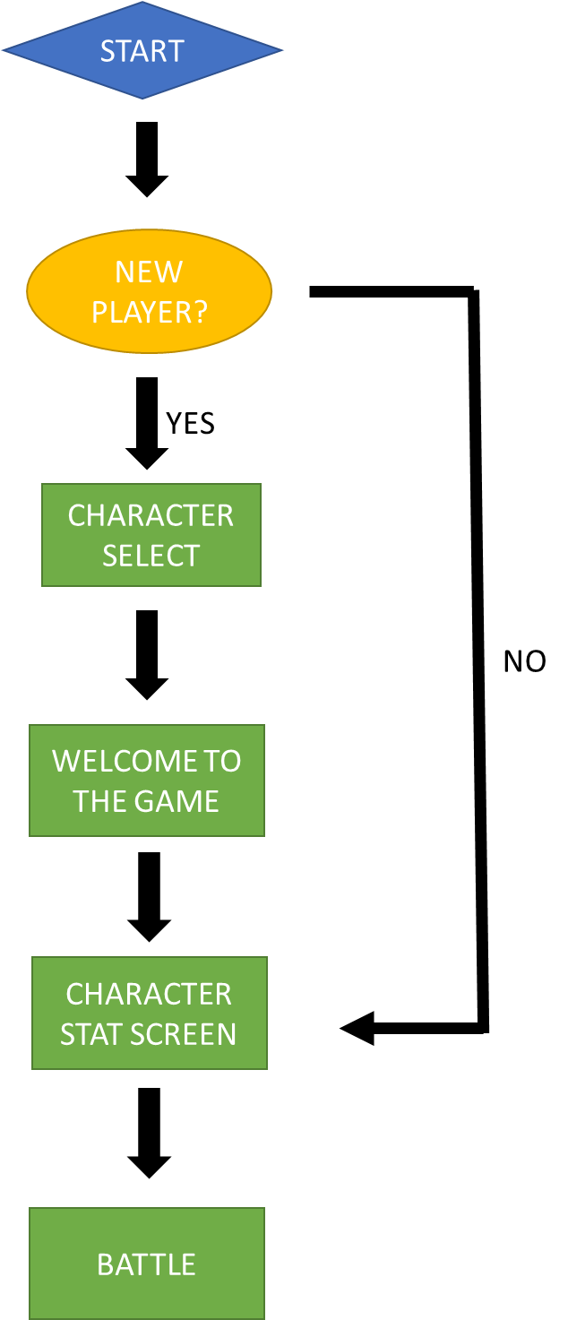

**Flowchart of how the game should progress through these different screens**

## Appendix 4 – Example User Consent Form

**User Testing Consent Form**

Study Administrator:

Participant:

Participant Number:

This study is focused around the gamification of mobile fitness applications, in particular on the smartwatch hardware platform. The intended audience for this product is tech-savvy young adults who want to engage in more physical fitness but may be in need of encouragement to do so.

For the testing period, you will be provided with a smartwatch with the required applications already installed. For 3 days, we would like you to simply track your steps using a provided step tracker, making note of the total amount of steps you’ve accumulated each day. Then, for the following 3 days, make use of the provided gamified step tracker and again keep note of the total steps taken each day.

The information that will be collected in the testing period will just be what you write in the testing diary supplied to you, which asks you to note down total number of steps you achieve each day and any thoughts you had on the experience.

**Statement of Informed Consent**

Upon signing this document, I indicate that I have read the description of the study and am aware of my rights as a participant. I voluntarily agree to participate in the study.

Print Name:

Signature:

Date:

**[Copies of completed user consent forms available upon request]**

## Appendix 5 – Example User Test Diary

|  |  |  |  |
| --- | --- | --- | --- |
| Steps Taken (Standard Tracker) | | Steps Taken (Game Tracker) | |
| Day 1 |  | Day 1 |  |
| Comments/ Notes |  | Comments/ Notes |  |
| Day 2 |  | Day 2 |  |
| Comments/ Notes |  | Comments/ Notes |  |
| Day 3 |  | Day 3 |  |
| Comments/ Notes |  | Comments/ Notes |  |

**[Copies of completed user test diaries available upon request]**

## Appendix 6 – Collated User Testing Data

|  |  |  |  |
| --- | --- | --- | --- |
| Standard Step Tracker | | | |
|  |  |  |  |
|  | Steps Taken | | |
| User | Day 1 | Day 2 | Day 3 |
| 1 | 7845 | 8123 | 8048 |
| 2 | 5320 | 5679 | 4365 |
| 3 | 11028 | 8935 | 9633 |
| 4 | 6791 | 6932 | 7639 |
| 5 | 8303 | 7209 | 7344 |
| 6 | 6849 | 7039 | 5603 |

|  |  |  |  |
| --- | --- | --- | --- |
| Game Steps Tracked | | | |
|  |  |  |  |
|  | Steps Taken | | |
| User | Day 1 | Day 2 | Day 3 |
| 1 | 8612 | 9021 | 8703 |
| 2 | 4902 | 5631 | 4743 |
| 3 | 8482 | 10238 | 12037 |
| 4 | 7802 | 8932 | 9831 |
| 5 | 7829 | 8528 | 8907 |
| 6 | 8023 | 9110 | 10622 |